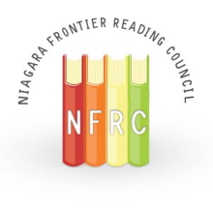
Spotlight
Volume LXIV, No. 3
ILA Honor Council - #35575
March 2022

Co-Presidents’ Messages

Co-president’s Message from Ashlee Campbell
Looking Ahead to Spring
Spring, and all the wonderful things it brings, is just around the corner. In spring, the sun sticks around longer, the weather shows glimpses of the good times to come, fresh aromas fill the air and our ears are tickled by the sounds of life and nature. What better way to celebrate this blossoming season than to update our libraries with the newest book releases. Please join us for our spring book event: Build Your Stack: Spring Book Fair & Share. On Wednesday, April 6th, from 5:00 to 6:30 p.m. Kim Krug from the Monkey See, Monkey Do mobile children’s bookstore, and Judy Bradbury, a local children’s book author and author of the Cayuga Island Kids book series, will present book talks on new releases. Then, participants can browse the books and buy the ones they like. This will be a free, in-person event, held at UB’s reading center, CLaRI, on UB’s North Campus. NFRC members will receive 20% off all purchases. Light refreshments will be served and there will be a raffle. We hope to see you there to learn about all the new, wonderful books we can use to build our stack.
-------------------------
Also happening this spring is our spring awards search. Do you know someone deserving of the Service to Reading award or the Certificate of Recognition award? If so, please consider nominating the person. Directions and the short nomination forms can be found on the NFRC website and in this issue of Spotlight. Both nominations are due by March 20th.

*****
Co-President's Message Spring 2022
“Reading gives us some place to go when we have to stay where we are.”
-Mason Cooley
It has often been said that books can take you wonderful places and introduce you to interesting people, even without leaving the comfort of your favorite chair. Likewise, your membership in the Niagara Frontier Reading Council and the New York State Reading Association can also allow you to participate in professional development events and interact with fellow educators, right from the comfort of home. Our Professional Book Discussion Group is just one example. We will be meeting again virtually on March 30, 2022. The other local councils of NYSRA also have planned a variety of programs and events, many of which are virtual and open to members from other councils. I invite you to peruse the Professional Development and Calendar of Events tabs of the NYSRA website, www.nysreading.org to discover opportunities provided by other councils that may be of interest to you. You will find a wide range of events, from a virtual Trivia Night hosted by the CNY Reading Council to presentations on technology and literacy. I especially hope to see you at one of our NFRC events.
In addition, we are excited to be meeting in-person for a spring event in the beginning of April! You will find the details about this event in this newsletter.
As always, we are looking for individuals who are interested in becoming involved in the Niagara Frontier Reading Council. If you would like to have a more active role in the NFRC, please contact me at heidiread@yahoo.com. I also welcome suggestions for future events and book recommendations!
Happy reading,
Heidi Clarke, Co-President
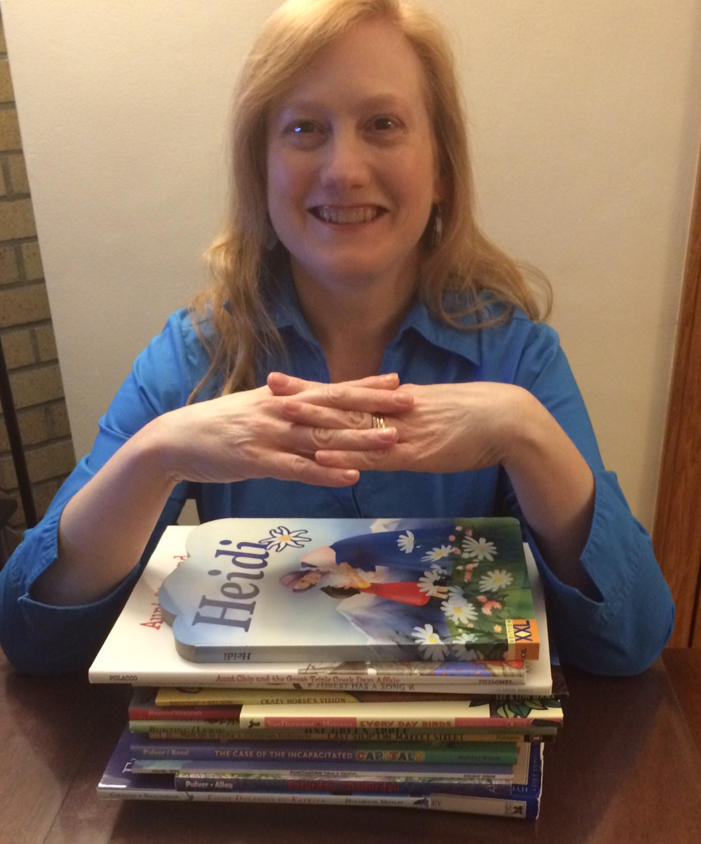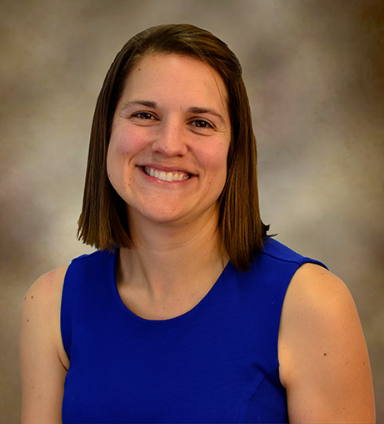
Heidi Clarke Ashlee Campbell

Professional Book Discussion Group Concludes Study of SEL

The NFRC Professional Book Discussion Group will meet via Zoom on Wednesday, March 30th from 6:30-8:30pm to discuss Chapters 5-7 in All Learning Is Social and Emotional: Helping Students Develop Essential Skills for the Classroom and Beyond by Nancy Frey, Douglas Fisher, and Dominique Smith.
The meeting is open to all NFRC and NYSRA chapter members. NFRC board member Patty Oliphant will lead the discussion. Two CTLE credits will be available to all participants.
Did you miss our discussion of the initial chapters of All Learning Is Social and Emotional: Helping Students Develop Essential Skills for the Classroom and Beyond? No worries! You are welcome to join us! The book is still available through local bookseller Kim Krug at Monkeys Read (books@monkeysread.com or 716-204-8417). Kim is offering NFRC members a generous educator discount and free delivery within 25 miles of Clarence, NY. The book is also available through other booksellers and online.
Pre-registration for the meeting is required; please register here by Sunday, 3/27 to receive the link to join the meeting.
Questions? Contact Judy Bradbury at judybradburywrites@gmail.com.
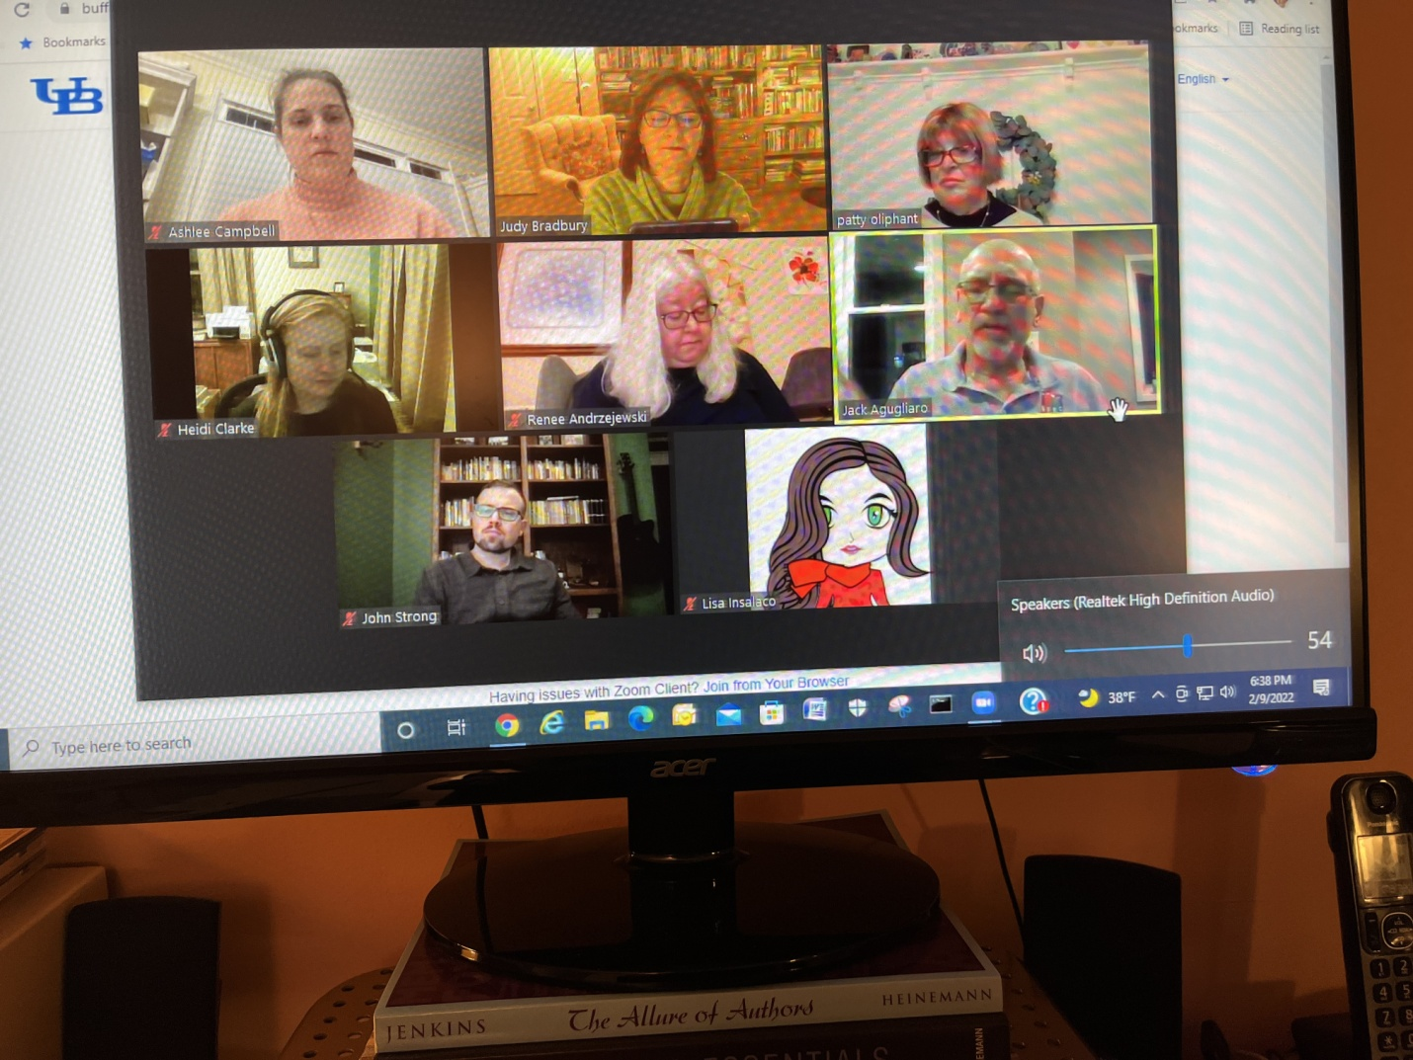

IN CASE YOU WERE WONDERING WHAT A ZOOM MEETING LOOKS LIKE FOR THE BOOK DISCUSSION, JUDY SENT ALONG THIS PICTURE AS WE WERE SHARING INFORMATION ABOUT SOCIAL EMOTIONAL LEARNING!
Social Media!

New social media platforms have been created by NFRC members Christiana Kfouri and Tiffany Karalis Noel They are as follows:

GMAIL Account
Email: nfrcreads@gmail.com

INSTAGRAM Account: https://www.instagram.com/nfrccommunity/

TWITTER Account: https://twitter.com/NFRCcommunity

**********

The NFRC Wants You!
If any member would like to take a more active role in the NFRC, please email Heidi Clarke at heidiread@yahoo.com.

********************************************************

Free Event: Build Your Stack - Spring Book Fair & Share - April 6
You're Invited...
Event: Build your Stack: Spring Book Fair & Share
Date: Wednesday, April 6th 5:00 to 6:30 p.m.
Location: CLaRI
(17 Baldy Hall, Buffalo, NY 14260- North Campus)
Light Refreshments will be served
We will be listening to Kim Krug and Judy Bradbury talk about newly released books, have a chance to see all the books, and a chance to buy these books.
This is a free event and there will be raffles.
Registration link

Every Child a Reader and the Children’s Book Council announced that the 2022 Children’s Book Week takes place May 2–8 and November 7–13. This year’s theme “How Do You Book?” promotes conversations with children about why they choose to read the books they do. Also, plans are underway to celebrate the first annual Floyd Cooper Day on May 6, in honor of the late children’s author/illustrator. Children’s Book Week posters and activities are available free to homes, schools, and libraries. Register here. Judy Bradbury

NFRC Local Awards
Every year the Niagara Frontier Reading Council presents two prestigious local awards, the Service to Reading Award and the Certificate of Appreciation Award.
We would love to hear who you think deserves the awards.

Nominations are due March 20th
​
The Service to Reading Award | Certificate of Recognition
- Will be given to a person, involved in literacy education, who has made a significant contribution promoting literacy in the community.  - The recipient should be a member of the Niagara Frontier Reading Council. |  | - Will be awarded to a person or a group not affiliated with the Niagara Frontier Reading Council and not a paid, professional educator.  - The Certificate of Recognition is for service to, or promotion of, the council’s goals.
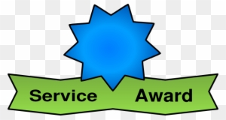

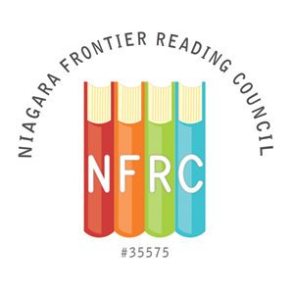
NFRC SERVICE TO READING AWARD NOMINATION FORM

The Service to Reading Award will be given to a person, involved in literacy education, who has made a significant contribution to promoting literacy in the community. The recipient should be a member of the Niagara Frontier Reading Council.

The deadline for nomination submission is March 20, 2022

Submit completed form to: Niagara Frontier Reading Council @ thenfrc@gmail.com
Please state “NFRC Awards” in the subject line

Person Submitting Nomination

Name: ________________________________________________________________________
Address:______________________________________________________________________

________________________________________________________________________

Phone:_______________________Email:____________________________________________

Nominee Information

Name: ________________________________________________________________________
Address:______________________________________________________________________

_______________________________________________________________________

Phone:_______________________Email:____________________________________________

Institutional Affiliation:__________________________________________________________

Position:_____________________________________________________________________
Please provide a description of the nominee’s contribution to promoting literacy in the community (please limit description to one page, single, spaced, 12pt font).
NFRC CERTIFICATE of RECOGNITION AWARD NOMINATION FORM

A Certificate of Recognition will be given to a person or a group not affiliated with the Niagara Frontier Reading Council and not a paid, professional educator. The Certificate of Recognition is for service to, or promotion of, the council’s purposes.

The deadline for nomination submission is March 20, 2022

Submit completed form to: Niagara Frontier Reading Council @ thenfrc@gmail.com
Please state “NFRC Awards” in the subject line

Person Submitting Nomination

Name: ________________________________________________________________________
Address:______________________________________________________________________

_______________________________________________________________________

Phone: _______________________Email:___________________________________________

Nominee Information

Name: ________________________________________________________________________
Address:______________________________________________________________________

_______________________________________________________________________

Phone: _______________________Email:___________________________________________

Institutional Affiliation:__________________________________________________________

Position:______________________________________________________________________
*Repeat the above information for each person if a group is being nominated
**Please provide a description of the nominee’s contribution to promoting literacy in the community (please limit description to one page, single, spaced, 12pt font).
Reflection

I think I am having a reflective moment or time or span, but it has to do with my observations made through conversations, newspapers, newscasts, magazines and the internet. In taking in cultural interchange as it is now, I have realized that I am only on the sidelines. I absorb information, but I can’t really do much about it. There is an overwhelming sense of stress that grew from the pandemic and our attempts to mitigate it. I have seen many teachers, friends, relatives and even strangers move to deal with unprecedented changes – where there is no manual or on-line set of instructions, or even a mentor who can guide others as to what to do.
I have heard of the struggles teachers, parents and students have encountered. Instruction methods that had been relied on were modified and, suddenly, everyone became a new learner. It has been hard to address the educational process which had already been going through constant metamorphosis for years with no firm base of longevity from which to grow.
I received the March 2022 issue of Educational Leadership which actually focuses on leadership this time. Here are some titles, subtitles and blurbs from this “Adaptive Leader” issue:
How to Be a More Adaptive Leader
What Kind of Leader Do Teachers Need in a Crisis?
Build Change in a School
How educators can apply adaptive leadership theory to navigate challenges
Prioritize Supporting Teachers
Linking Continuous Improvement and Adaptive Leadership
Different leadership for a Different Time
Being an adaptive leader means knowing when to shift your old ways of thinking and embrace new best practices
I heard of teachers “taking the bull by the horns” during the pandemic. I also heard about teachers throwing their arms up in the air, feeling they were ineffectual. Some crumbled under the new pressures. Although educational leaders were also affected by the disruption, they were still saddled with the task of running the schools.
I find that there may be a lack in the addressing of teacher stress concerns. There need to be programs developed that just plan a pause, continue instruction in the best way as it stands, and address what can only be called Educational PTSD. The teachers are the ones in direct contact with students. They must be taken care of through some framework to bolster the “internal teachers” they are. Education is going to be different from now on. There is no more “the same way we did it”, or whatever normal was. I believe there needs to be a collective sigh before we can again start the educational machine that calls for constant improvement in instruction.
Jack Agugliaro, editor
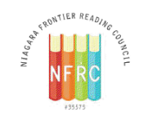
NFRC 2021-2022 Officers & Board Members

NFRC Officers 2021-2022
- Co-President - Heidi Clarke
- Co-President for Programming - Dr. Ashlee Campbell
- Secretary - Jack Agugliaro
- Treasurer - Dr. John Strong
- Director of Membership - Carol Bush

Board Members 2020 - 2022
- Judy Bradbury
- Pamela Garabedian
- Patty Oliphant
- Lindsey Buck

Board Members 2021 - 2023
- Elizabeth Bystrak
- Dr. Tiffany Karalis-Noel
- Christine Woodcock
- Mary Beth Scumaci
Chairperson Positions
Editor of Spotlight- Jack Agugliaro
Web Designer & Editor- Mary Beth Scumaci
Social Media Chair- Dr. Tiffany Karalis-Noel & Dr. Christiana Kfouri
Council Awards Chair- Elizabeth Bystrak
Professional Development Chair- Judy Bradbury
Outreach Chair- Pamela Garabedian; Co-Chair: Judy Bradbury to oversee Little Free Libraries project
CTLE Chair/ Mini Grants Chair-Patricia Oliphant
Finance / Budget Chair-
Nominating Chair - Comprised of the Board
Liaison Chair- Jack Agugliaro
Audit Chair -
Western Regional Director 2018-21, NYSRA - Cherie Gerych

About the NFRC:
• We are non-profit educational organization chartered by The International Literacy Association since 1958.
• We are dedicated to the professional development and enhancement of literacy in our community.
• We are involved in professional issues affecting literacy.

NFRC Mission:
Our mission is to promote literacy education, encourage professional development, and provide community service, which fosters literacy within Western New York. We hope to instill a passion for lifelong learning and encourage readers to build a vision of the future.
*****

Upcoming Events

*Professional Book Discussion Group – March 30, 2022, 6:30 – 8:30 p.m. by Zoom.

*Build Your Stack: Spring Book Fair & Share – April 6, 2022, ClaRI @ UB

