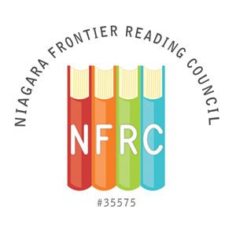
NFRC SERVICE TO READING AWARD NOMINATION FORM

The Service to Reading Award will be given to a person, involved in literacy education, who has made a significant contribution to promoting literacy in the community. The recipient should be a member of the Niagara Frontier Reading Council. This award will be presented at the Spring Brunch by the Awards Chair. The deadline for nomination submission is March 20, 2021

Submit completed form to: Elizabeth Bystrak
elibystrak@gmail.com (Please list NFRC Awards in the subject line)
or by mail at 6 Knob Hill Road, Orchard Park, NY 14127

Person Submitting Nomination

Name: _________________________________________________
Address: _________________________________________________

_________________________________________________

Phone: _____________________________
Email: _____________________________

Nominee Information

Name: _________________________________________________

Address: _________________________________________________

_________________________________________________

Phone: _____________________________
Email: _____________________________

Institutional Affiliation: ______________________________________

Position: ___________________________________________

Please provide a description of the nominee’s contribution to promoting literacy in the community (please limit description to one page, single, spaced, 12pt font).

