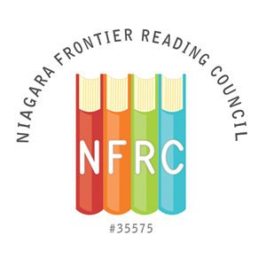
NFRC CERTIFICATE of RECOGNITION AWARD NOMINATION FORM

A Certificate of Recognition will be given to a person or a group not affiliated with the Niagara Frontier Reading Council and not a paid, professional educator. The Certificate of Recognition is for service to, or promotion of, the council’s purposes. This award will be presented at the Spring Brunch by the Awards Chair. The deadline for nomination submission is March 20, 2021

Submit completed form to: Elizabeth Bystrak
elibystrak@gmail.com (Please list NFRC Awards in the subject line)
or by mail at 6 Knob Hill Road, Orchard Park, NY 14127

Person Submitting Nomination

Name: _________________________________________________

Address: _________________________________________________

_________________________________________________

Phone: _____________________________

Email: _____________________________

Nominee Information

Name: _________________________________________________

Address: _________________________________________________

_________________________________________________

Phone: _____________________________
Email: _____________________________

Institutional Affiliation: ______________________________________

Position: ___________________________________________

*Repeat the above information for each person if a group is being nominated

Please provide a description of the nominee’s contribution to promoting literacy in the community (please limit description to one page, single, spaced, 12pt font).

