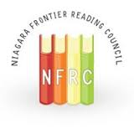
NIAGARA FRONTIER READING COUNCIL
SAVE THE DATE

WINTER BRUNCH
FEBRUARY 4, 2017, Classics V

Guest Speaker: Amy Ludwig VanDerwater
Come join us and get a sneak-peak of her upcoming book.

Poems Are Teachers:
How Poetry Helps Strengthen Our Writing in all Genres

Because a poem is usually built from a small number of lines, studying poetry allows readers to understand a poem’s design all in one look, to notice metaphor and other artful language all on the same page. From one handful of carefully chosen words, students can see how a poem works line-by-line, discovering ways to both find ideas and play with sound. And when writers understand how poems are sewn together, they can use the stitches of structure and repetition, meter and image to craft any text, from poetry to narrative, from opinion to information. Come study poems, the most elegant writing teachers of all.

