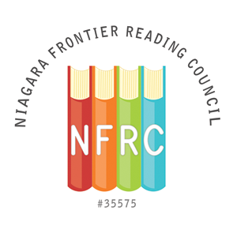

NFRC CERTIFICATE of RECOGNITION AWARD NOMINATION FORM

A Certificate of Recognition will be given to a person or a group not affiliated with the Niagara Frontier Reading Council and not a paid, professional educator. The Certificate of Recognition is for service to, or promotion of, the council’s purposes. This award will be presented at the Spring Brunch by the Awards Chair.
The deadline for nomination submission is March 15, 2015.

Submit completed form to: Susan Hirsch (shirsch2@verizon.net)

Person Submitting Nomination
Name:

Address (Street, Apt/Unit #):

Address (City, State, Zip Code):

Phone:

Email:

Nominee Information

Name:

Address (Street, Apt/Unit #):

Address (City, State, Zip Code):

Phone:

Email:

Institutional Affiliation:

Position:

**Repeat the above information for each person if a group is being nominated.
Please include a description of the nominee’s contribution to promoting literacy in the community. (Please limit description to one page, single spaced, 12pt font.)

