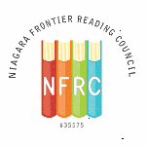
NFRC Members and Friends
Saturday, August 24, 2019
10:00 AM – 12 Noon
Join NFRC at Barnes and Noble
Niagara Falls Boulevard Store
10:00 What’s New in Children’s and YA Literature- presentations by B&N staff
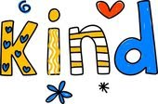
11:00 Using Literature in Teaching Kindness
And Social Emotional Competencies by NFRC
CTLE Credits available for NFRC members
25% discount on all purchases
Free coffee
